Real-Time Stock Market Analytics Pipeline Project Proposal
Developer: Rishabh Gupta
Target Audience: Investors, financial analysts, students, and users interested in stock market trends and financial analytics.
Technology Stack: Python, Dash/Power BI, Plotly, Alpha Vantage API, Pandas, SQLite/PostgreSQL
Background
This project proposes the development of a real-time stock market analytics application that collects financial market data using the Alpha Vantage REST API and transforms it into interactive visual dashboards for analysis and decision-making
Business Problem
Stock market information is often scattered across multiple platforms and presented in raw numerical formats that are difficult to analyze efficiently. Investors and analysts need an automated pipeline that can continuously retrieve, clean, store, and visualize stock market data for better decision-making and trend analysis.
This project addresses the challenge of converting raw API-based stock market data into meaningful and interactive business insights.
Objectives
- Create an interactive stock market analytics dashboard using Dash or Power BI
- Integrate real-time and historical stock data from Alpha Vantage API
- Build a complete ETL (Extract, Transform, Load) data pipeline
- Develop automated workflows for scheduled stock data updates
- Visualize stock price trends, trading volume, and moving averages
- Provide comparative analysis between multiple companies
- Generate business insights through interactive charts and KPIs
Technical Approach
1. Stock Market Dashboard
- Current stock price
- Daily price changes
- Percentage gain/loss
- Trading volume
2. Visual Analytics
- Interactive line charts
- Candlestick charts
- Volume bar charts
- KPI cards
- Trend analysis visualizations

Technical Architecture + Diagram
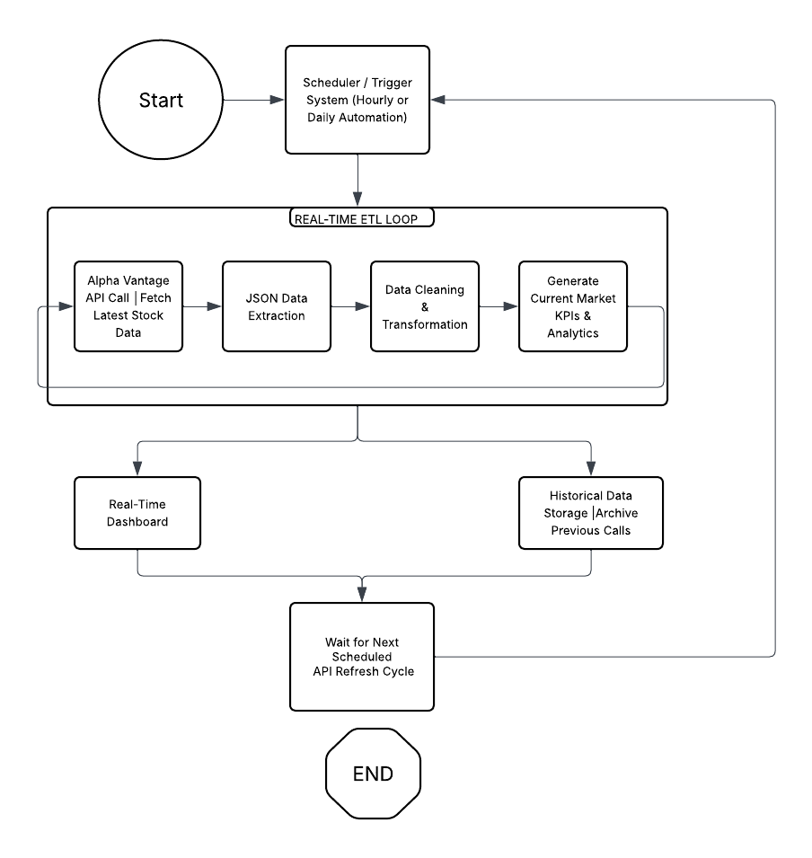

Data Flow
- Extract stock market data from Alpha Vantage API
- Receive raw JSON responses
- Transform JSON into structured datasets
- Clean and standardize stock data
- Load processed data into database
- Visualize financial insights in dashboard
- Schedule automated updates for continuous refresh

Data Sources and APIs
Primary Data Source: https://www.alphavantage.co
- Endpoint: https://www.alphavantage.co/query?function=TIME_SERIES_DAILY&symbol=AAPL&apikey=YOUR_API_KEY
Data Parameters:
- Open price
- Close price
- High price
- Low price
- Trading volume
- Date/time
Implementation Plan
Phase 1: Research & Setup (Week 1)
- Research Alpha Vantage API
- Set up project structure
- Create API connection scripts
- Design ETL workflow
Phase 2: Data Extraction & Transformation (Week 2)
- Implement API extraction pipeline
- Parse and clean JSON data
- Transform stock data into tables
Phase 3: Database & Storage (Week 3)
- Design database schema
- Store stock data in SQLite/PostgreSQL
- Test historical data storage
Phase 4: Dashboard Development (Week 4)
- Build interactive dashboard
- Create charts and KPIs
- Add filters and comparisons
Phase 5: Testing & Finalization (Week 5)
- Test complete pipeline
- Optimize performance
- Finalize documentation and presentation

Success Metrics
Technical Metrics
- Successful automated API extraction
- Data refresh reliability
- Database consistency
- Dashboard responsiveness
User Experience Metrics
- Easy dashboard navigation
- Interactive filtering capability
- Accurate financial insights
Educational Metrics
- Demonstrates ETL pipeline implementation
- Shows practical API integration
- Demonstrates real-world data engineering workflow

Expected Outcomes
The completed project will produce:
- A fully functional ETL pipeline
- Automated stock market data extraction system
- Structured financial database
- Interactive financial analytics dashboard
- Real-time stock trend visualizations
- Analytical business insights for market analysis
Conclusion
This project provides a realistic and technically complete implementation of a modern data engineering pipeline using financial market data. By combining REST API integration, ETL processing, database management, and interactive dashboard development, the project demonstrates practical real-world applications of data engineering and analytics.

